

Model for CAPTCHA Breaking system using Neural networks

A project report submitted to Dr. Ganala Santoshi Sir, SCOPE
In fulfilment of the requirements for the course of CSE4015 –
Human Computer Interaction
B. Tech. COMPUTER SCIENCE ENGINEERING

Aman Kr. Mishra – 20BCE1382
Ansh Goel – 20BCE1798

Vandalur – Kelambakkam Road
Chennai – 600127
November 2022

Abstract
Captcha or Completely Automated Public Turing test to tell Computers that the operator is human or not. Almost every website now have process of checking whether the website is being crawled by some sort of automated bots or not .Earlier there was too much attacks on the website using bots which used to cause a lot of harm to the big companies so they invented Completely Automated Public Turing test to tell Computers and Humans Apart which no doubt helped them a lot in preventing the attacks via bots but now the world is much more advanced and with some lines of codes we can break various types of captchas and that is what we are doing in this paper proving the point that now captchas are just a matter of hindrance that decreases the human experience with the various websites as even sometimes they cannot enter the captcha that a bot can easily break and waste the important time of human. So here in our study we proved our point by breaking the various sorts of captchas like numerical, alphanumerical, circle captcha, captcha v2 etc. We are proving our points by getting pretty good accuracies. We used Convolutional neural network for our purpose some captchas were easy to break with only a few layers while some took pretty big networks. In the end we will also be discussing some ways that makes the websites more secure and much easy for the humans to enter a website.Text-based CAPTCHAs are most commonly used by various websites to distinguish between humans and computers. It is used as a security measure. This work consists of a dynamic approach that is proposed to predict Text-based CAPTCHAs that challenges the supposition that they cannot be solved by computers. Three types of CAPTCHAs namely Rotated, Noisy Arc, Complicated Background have been taken.

Introduction
CAPTCHA stands for Completely Automated Public Turing test it was developed to distinguish humans and computers. CAPTCHA system or Reverse Turing test deals with bots acting as an interrogator. Here the bot is said to pass the Turing test if it always correctly differentiates between a human and a computer or a bot. With the help of the bots used for cracking the captchas the attackers try to perform cyber-attacks. Distributed denial-of-service does not help the attacker in getting any sort of private information of the company or any data which the attacker may sell and get some good amount of money.
Some of the common captchas that the websites used are numerical or alphanumerical where we get about 98% and 99% accuracy and the captcha version2 where we were able to get 90% accuracy. It is just a race between the captcha developers and the hackers the developers come up with some unique sort of captcha and hackers just find the way out to crack it.

Existing Systems
There are a few apps available for labelling the captcha, whatever it may be. We will be grateful for this application because without it, there would have been no dataset to train on these various types of captchas and no model available. There have undoubtedly been other people working on captcha breaking with various captchas such as jam captcha, multicolor, minibatch, railway reCAPTCHA, and so on. In the jam captcha you have to solve a very basic addition or subtraction. This captcha has been seen in various universities. Here is the example of the example where the jam captcha is used. This is an IIT’s website



They classified the digits using k-NN, a K-nearest neighbour ensemble technique. They created the dataset by labelling them on their own, which was a laborious task. But the problem is that, in general, we humans do not have much difficulty solving jam captchas, and they are also not very time consuming because we only need to enter a digit.
There is also research on the faded captcha, which has the alphanumeric very faded with a lot of clutter and noise. The letters are distributed uniformly here. Websites should avoid using this type of captcha because the letters are difficult to read for humans as well, resulting in a poor user experience.

Problem Statement
Text-based CAPTCHAs are most common but we believe that it should not be used and is just a hurdle for the users which irritates them and to prove that we’ll be breaking the captcha using various neural networks. It’ll save the time of the users and prevent them from unnecessary steps, when we enter the captcha wrong we just have to enter our whole details again which is irritating to the user.

Introduction to Proposed model
- Numerical captcha / Railway captcha
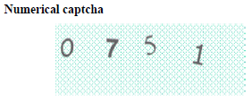
The original size of the image data used in this study was 135 50 pixels; we reduced the image size to 67 25 pixels because unnecessary padding complicates model learning. We trained the network on 500,000 randomly generated CAPTCHAs generated with the Python Image Captcha Library and 500,000 numerical CAPTCHAs with fixed lengths of five numeric. This is a summary of the model we used to crack the numerical captcha. This model is not very large, but it has a high degree of accuracy.

- Captcha V2
This dataset can also be found online on Kaggle (https://www.kaggle.com/fournierp/captcha-version-2-images).
We printed the frequency of the numeric and alphabets in the dataset and the results were good the numeric and alphabets in which the human gets confused like “I” and “1” and “O” and “0” are avoided totally which is a good approach.It is obvious that classifying the labels of such a dataset presents a significant challenge. The reason for this is that there is some noise in the dataset in the form of clutter and scratch.Initially, we employed an Alex Net type model, which can recognise CAPTCHAs that are obscured by noise. The accuracy obtained during training was approximately 97.87%, and the accuracy obtained during testing was approximately 76.54%, which was quite low, but we changed our model and were able to achieve approximately 90% accuracy.This is a summary of our model as well as a graph of model accuracy. The model used here is quite large, which caused overfitting, so we added a slew of dropout layers.
- Fish Eyed Captcha
We can see there is a lot of variety in this type of CAPTCHA. This type of CAPTCHA poses a real challenge to machine learning systems.There is grid, a line and bold letters which is occluded by lines of different colors. The deep learning model needs to learn each of the representation of the CAPTCHA dataset.It took about 3902 second per epochs and there was a total of 5 epochs The accuracy obtained on training’s validation set was about 94.49 % and the same for test dataset was 91.46 % which was pretty great given that the model converges in only 5 epochs.

Proposed Solution
Text-based CAPTCHAs are most common but we believe that it should not be used and is just a hurdle for the users which irritates them and to prove that we’ll be breaking the captcha using various neural networks. It’ll save the time of the users and prevent them from unnecessary steps, when we enter the captcha wrong we just have to enter our whole details again which is irritating to the user.

Components of the model
- Numerical Captcha
- Captcha V2
- Fish eyed captcha

Block Diagram (Explanation Required) For proposed work
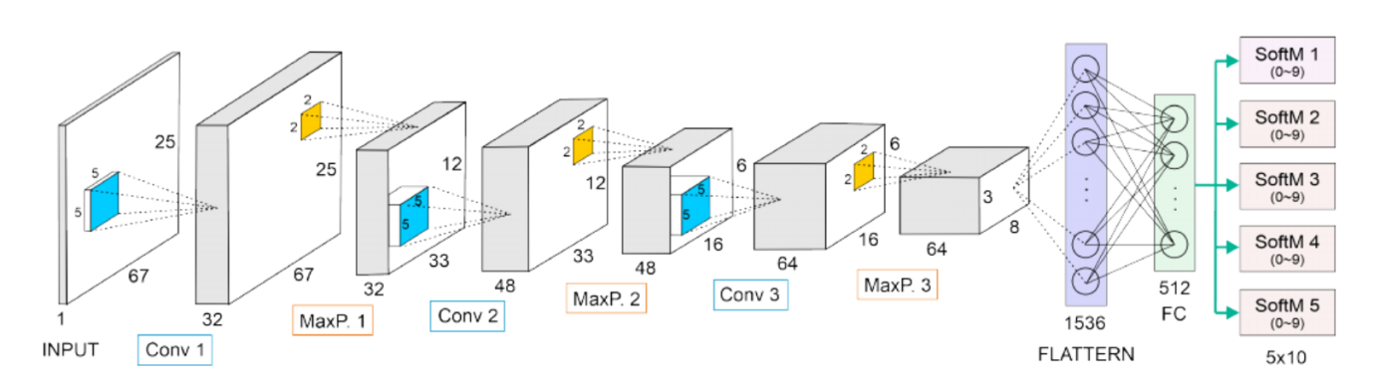
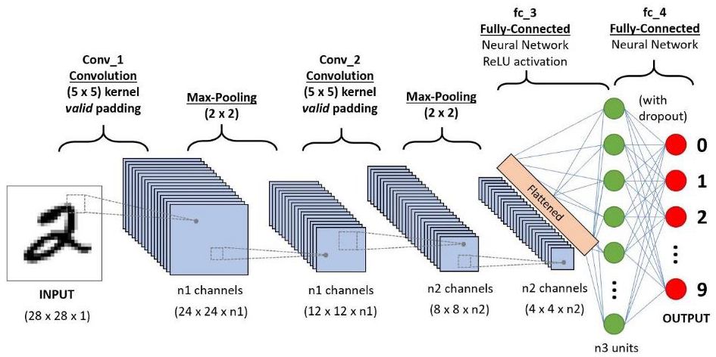

When the captcha is passed through neural network model first Convolution valid kernel padding is done then max pooling and again Convolutional kernel padding and again max-pooling is done then Fully-Connected Neural network ReLU activation and then Fully connected neural network model is established. This steps are followed for each and every captcha image.

.

Description of the components (HW / SW / Tech. Specifications)
To complete this project, we needed the following:
A local development environment for Python 3 with
- Modern Operating System:
- Windows 7 or 10
- Mac OS X 10.11 or higher, 64-bit
- Linux: RHEL 6/7, 64-bit (almost all libraries also work in Ubuntu)
- x86 64-bit CPU (Intel / AMD architecture)
- 4 GB RAM
- 5 GB free disk space
- A working webcam to do real-time image detection.
We will build a sign language classifier using a neural network. Our goal is to produce a model that accepts a picture of a hand as input and outputs a letter.
Python 3 - Python is a fun programming language with great libraries for machine learning and computer vision.
OpenCV - OpenCV is a popular framework for computer vision and image processing. We’ll use OpenCV to process the CAPTCHA images. It has a Python API so we can use it directly from Python.
Keras - Keras is a deep learning framework written in Python. It makes it easy to define, train and use deep neural networks with minimal coding.
Pytorch - PyTorch is a library for Python programs that facilitates building deep learning project.

Working Mechanism
Our study has demonstrated that most captchas can be easily answered using only a few CNN models, and that in certain cases, the accuracy is similar to or even higher than that of humans. With the aid of multiple models, we will be able to acquire relatively decent accuracies in practically every captcha, indicating that these sorts of text-based captchas are not particularly dependable and put security at risk. We've also observed that basic data augmentation approaches are critical during model training because we may not always have access to the large datasets needed for better training. Although the algorithms were, in our judgement, pretty accurate, some circumstances made it incredibly tough. In addition, we've discovered that certain basic models provide extraordinarily high accuracies when compared to advanced models, which often result in overfitting. It is also essential that we visualise what we are doing at each level since it helps us obtain better results and a better understanding of the model used. We noticed that dropouts were quite good in reducing noise and effectively generalising on previously unknown data.

Flow Diagram / Flow Chart

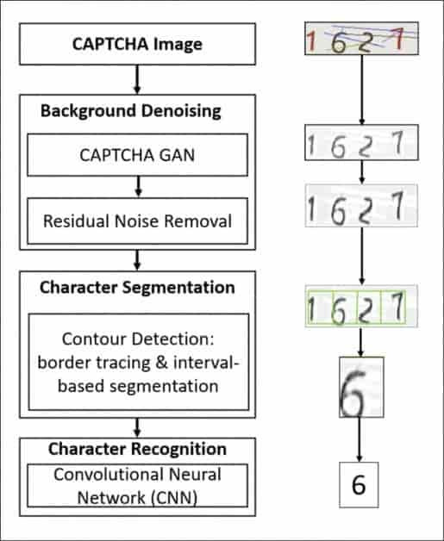

Model for our projects
For Railway Captcha

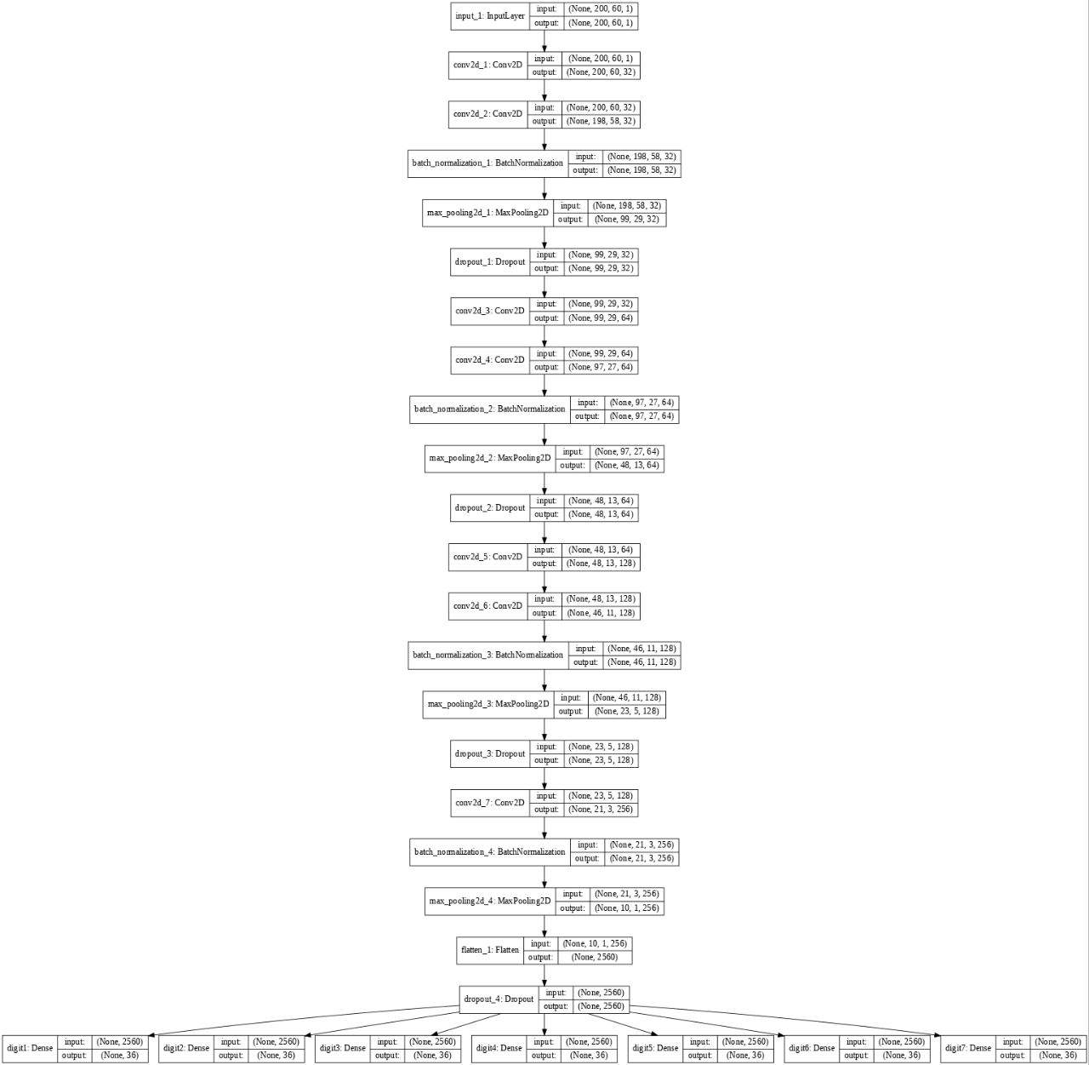
When the captcha is passed through neural network model first Convolution valid kernel padding is done then max pooling and again Convolutional kernel padding and again max-pooling is done then Fully-Connected Neural network ReLU activation and then Fully connected neural network model is established. This steps are followed for each and every captcha image for Railway captcha.
For Fish Eyed Captcha
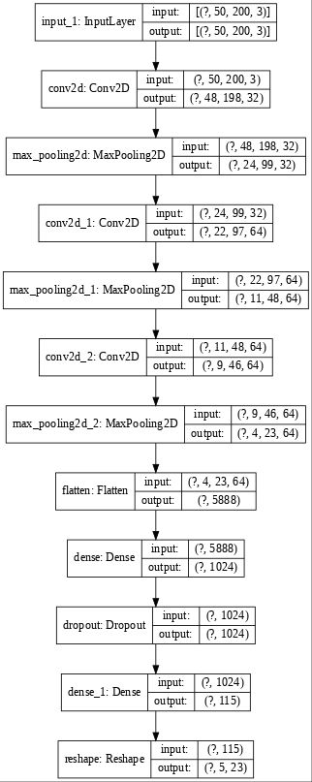
When the captcha is passed through neural network model first Convolution valid kernel padding is done then max pooling and again Convolutional kernel padding and again max-pooling is done then Fully-Connected Neural network ReLU activation and then Fully connected neural network model is established. This steps are followed for each and every captcha image for fish-eyed captcha.

For Circle Captcha
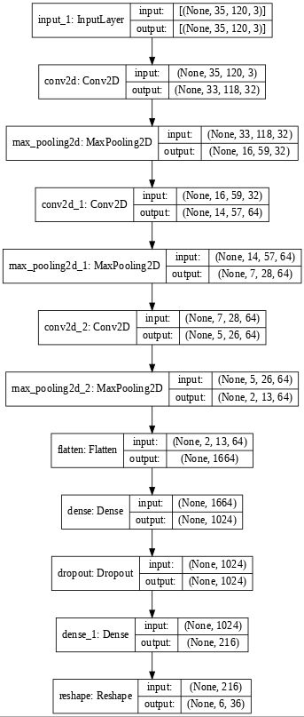

When the captcha is passed through neural network model first Convolution valid kernel padding is done then max pooling and again Convolutional kernel padding and again max-pooling is done then Fully-Connected Neural network ReLU activation and then Fully connected neural network model is established. This steps are followed for each and every captcha image for Circle Captcha.

Code (Input / Execution / Output)
- Railway Captcha
Code -:
import numpy as np
import glob
import pandas as pd
%matplotlib inline
import matplotlib.pyplot as plt
import os
%tensorflow_version 1.x
from PIL import Image
from keras import layers
from keras.models import Model
from keras.models import load_model
from keras.utils.vis_utils import plot_model
from keras import callbacks
from datetime import datetime
import os
import cv2
import string
import numpy as np

from keras.models import Model
from keras.layers import Input, Dense, Dropout, Flatten, Conv2D, MaxPooling2D, BatchNormalization
from keras.callbacks import ModelCheckpoint, EarlyStopping, TensorBoard
import warnings
warnings.filterwarnings('ignore')
from keras import models
from keras.models import Sequential
from keras.layers import Conv2D
from keras.layers import MaxPooling2D
from keras.layers import Flatten
from keras.layers import Dense
from keras.layers import Dropout
from keras.preprocessing import image
from keras.preprocessing.image import ImageDataGenerator
from keras.callbacks import ModelCheckpoint

from keras import layers
from keras.models import Model
from keras.models import load_model
from keras import callbacks
import cv2
import string
import numpy as np
from datetime import datetime
from packaging import version
import tensorflow as tf
from tensorflow import keras
! wget "https://ndownloader.figshare.com/files/22150851" -railway_captcha7.tar.gz
!tar -xvf railway_captcha7.tar.gz > /dev/null
! echo "Untaring... done..."
png_files = glob.glob('railway_captcha7/*.jpg')
print("Total # of files => ",len(png_files))
png_files[0]
symbols = "ABCDEFGHIJKLMNOPQRSTUVWXYZ" + '0123456789' # These are all symbols the captchas will have
num_symbols = len(symbols)
img = np.array(Image.open(png_files[0]))
shape_ = img.shape
print(shape_, num_symbols)
img_path = png_files[1]
img = cv2.imread(img_path,cv2.IMREAD_UNCHANGED)
plt.imshow(img)
plt.show()
img_path = png_files[1]
img_gray = cv2.imread(img_path,cv2.IMREAD_GRAYSCALE)
plt.imshow(img_gray,cmap='gray')
plt.show()
print(img_gray.shape)
# perform OTSU's thresholding
ret,thresh = cv2.threshold(img_gray,127,255,cv2.THRESH_BINARY_INV)
plt.imshow(thresh,cmap='gray')
plt.show()
print(thresh.shape)
kernel = np.ones((2,2),np.uint8)
#dialate = cv2.dilate(thresh,kernel,iterations = 1)
erosion = cv2.erode(thresh,kernel,iterations = 1)
plt.imshow(erosion,cmap='gray')
plt.show()
#kernel = np.ones((2,2),np.uint8)
dialate = cv2.dilate(erosion,kernel,iterations = 2)
#erosion = cv2.erode(thresh,kernel,iterations = 1)
plt.imshow(dialate,cmap='gray')
plt.show()
total_img = 36
num_pr = 6 # number per row

counter = 1
plt.figure(figsize=(30,15))
plt.axis('off')
for item in png_files[:total_img]:
image = cv2.imread(item, cv2.IMREAD_GRAYSCALE)
#img = cv2.resize(img, (200,60), interpolation = cv2.INTER_AREA)
ret,thresh = cv2.threshold(image,127,255,cv2.THRESH_BINARY_INV)
# firstly perform erosion
erosion = cv2.erode(thresh,kernel,iterations = 1)
# perform dialation
dialate = cv2.dilate(erosion,kernel,iterations = 2)

#print(pred)
image_bckup = dialate.copy()
plt.subplot(num_pr, num_pr, counter)
#print("item => ",item)
#print("item => ",str(item.split('_')[1]).split('/')[1])
plt.title("Name = {}".format(str(item.split('_')[1]).split('/')[1]),fontsize=20).set_color('black')
plt.axis('off')
plt.imshow(image_bckup, cmap=plt.get_cmap('gray'))
counter += 1
#break
plt.show()
def create_model():
in_ = Input(shape=img_shape)
out = in_
out = Conv2D(filters=32, kernel_size=(3, 3), padding='same', activation='relu')(out)
out = Conv2D(filters=32, kernel_size=(3, 3), activation='relu')(out)
out = BatchNormalization()(out)
out = MaxPooling2D(pool_size=(2, 2))(out)
out = Dropout(0.3)(out)
out = Conv2D(filters=64, kernel_size=(3, 3), padding='same', activation='relu')(out)
out = Conv2D(filters=64, kernel_size=(3, 3), activation='relu')(out)
out = BatchNormalization()(out)
out = MaxPooling2D(pool_size=(2, 2))(out)
out = Dropout(0.3)(out)
out = Conv2D(filters=128, kernel_size=(3, 3), padding='same', activation='relu')(out)
out = Conv2D(filters=128, kernel_size=(3, 3), activation='relu')(out)
out = BatchNormalization()(out)
out = MaxPooling2D(pool_size=(2, 2))(out)
out = Dropout(0.3)(out)
out = Conv2D(filters=256, kernel_size=(3, 3), activation='relu')(out)
out = BatchNormalization()(out)
out = MaxPooling2D(pool_size=(2, 2))(out)
out = Flatten()(out)
out = Dropout(0.3)(out)
out = [Dense(36, name='digit1', activation='softmax')(out),\
Dense(36, name='digit2', activation='softmax')(out),\
Dense(36, name='digit3', activation='softmax')(out),\
Dense(36, name='digit4', activation='softmax')(out),\
Dense(36, name='digit5', activation='softmax')(out),\
Dense(36, name='digit6', activation='softmax')(out),
Dense(36, name='digit7', activation='softmax')(out)
]
model = Model(inputs=in_, outputs=out)
model.compile(loss='categorical_crossentropy', optimizer='adam', metrics=['accuracy'])
return model
from tqdm import tqdm
kernel = np.ones((2,2),np.uint8)
letters_in_captcha = 7
def preprocess_data():
n_samples = len(os.listdir('railway_captcha7/'))
X = np.zeros((n_samples, 200, 60, 1)) #1070*50*200
print(num_symbols,n_samples)
y = np.zeros((letters_in_captcha, n_samples, num_symbols)) #5*1070*36
for i, pic in tqdm(enumerate(os.listdir('railway_captcha7/'))):
# Read image as grayscale
img = cv2.imread(os.path.join('railway_captcha7/', pic), cv2.IMREAD_GRAYSCALE)
ret,thresh = cv2.threshold(img,127,255,cv2.THRESH_BINARY_INV)
# firstly perform erosion
erosion = cv2.erode(thresh,kernel,iterations = 1)
# perform dialation
dialate = cv2.dilate(erosion,kernel,iterations = 2)
img = dialate.copy()
pic_target = pic.split('_')[0]
img = img / 255.0
#plt.imshow(img,cmap='gray')
img = np.reshape(img, (200, 60, 1))
# Define targets and code them using OneHotEncoding
targs = np.zeros((letters_in_captcha, num_symbols))
#print("num symbols = ",num_symbols)
for j, l in enumerate(pic_target):
ind = symbols.find(l)
targs[j, ind] = 1
X[i] = img
y[:, i] = targs

# Return final data
return X, y

X, y = preprocess_data()
X_train, y_train = X[:90000], y[:, :90000]
X_test, y_test = X[90000:], y[:, 90000:]
plt.imshow(X_train[0].reshape((60,200)),cmap='gray')
plt.show()
print(X_train[0].shape)
img_shape = (200, 60, 1)
model=create_model();
model.summary();
plot_model(model, to_file='model_plot.png', show_shapes=True, show_layer_names=True,dpi=60)
# for storing logs into tensorboard
logdir="logs/fit/" + datetime.now().strftime("%Y%m%d-%H%M%S")
tensorboard_callback = keras.callbacks.TensorBoard(log_dir=logdir)

hist = model.fit(X_train, [y_train[0], y_train[1], y_train[2],y_train[3],y_train[4],y_train[5],y_train[6]], batch_size=32, epochs=30,verbose=1, validation_split=0.2,callbacks=[tensorboard_callback])
plt.figure(figsize=(12,7))
legend_acc = []
for item in hist.history.keys():
if item.split('_')[-1:] == ['acc']:
#print("Accuracy = ",item)
legend_acc.append(item)
plt.plot(hist.history[item])
plt.ylabel('Accuracy ->')
plt.xlabel('Epoch ->')
plt.legend(legend_acc, loc='upper left')
plt.show()

plt.figure(figsize=(12,7))
legend_acc = []
for item in hist.history.keys():
if item.split('_')[-1:] == ['loss']:
#print("Accuracy = ",item)
legend_acc.append(item)
plt.plot(hist.history[item])
plt.ylabel('Loss ->')
plt.xlabel('Epoch ->')
plt.legend(legend_acc, loc='upper right')
plt.show()
# Define function to predict captcha
def predict(filepath):
img = cv2.imread(filepath, cv2.IMREAD_GRAYSCALE)
ret,thresh = cv2.threshold(img,127,255,cv2.THRESH_BINARY_INV)
# firstly perform erosion
erosion = cv2.erode(thresh,kernel,iterations = 1)
# perform dialation
dialate = cv2.dilate(erosion,kernel,iterations = 1)
img = dialate.copy()
if img is not None:
img = img / 255.0
else:
print("Not detected");
#res = np.array(model.predict(img[np.newaxis, :, :, np.newaxis]))
new_im = img.reshape((img.shape[1],img.shape[0]))
res = np.array(model.predict(new_im[np.newaxis,:,:,np.newaxis]))
#print(res)
ans = np.reshape(res, (7, 36))
l_ind = []
probs = []
for a in ans:
l_ind.append(np.argmax(a))
#probs.append(np.max(a))

capt = ''
for l in l_ind:
capt += symbols[l]
return capt#, sum(probs) / 5
total_img = 36
num_pr = 6 # number per row

counter = 1
plt.figure(figsize=(30,15))
plt.axis('off')
for item in png_files[:total_img]:
image = cv2.imread(item, cv2.IMREAD_UNCHANGED)
pred = predict(item)
#print(pred)
image_bckup = image.copy()
plt.subplot(num_pr, num_pr, counter)
#print("item => ",item)
#print("item => ",str(item.split('_')[1]).split('/')[1])
if str(item.split('_')[1]).split('/')[1] == str(pred):
plt.title("Prediction = {}".format(pred),fontsize=20).set_color('green')
else:
plt.title("Prediction = {}".format(pred),fontsize=20).set_color('red')
plt.axis('off')
plt.imshow(image_bckup, cmap=plt.get_cmap('gray'))
counter += 1
#break
plt.show()
score= model.evaluate(X_test,[y_test[0], y_test[1], y_test[2],y_test[3],y_test[4],y_test[5],y_test[6]])
print('Test Loss and accuracy:', score)

Single user input
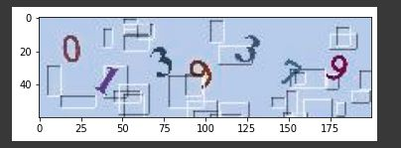

This is the sample user input for the model.

Steps involved in single captcha processing

Each captcha passed through model is converted into gray scale as shown below
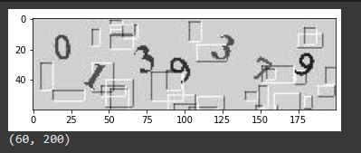
After making it on gray scale the background of the captcha is changed so that all the letters and disruptions can be seen clearly
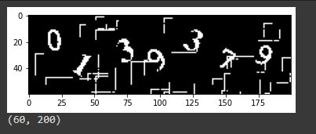

The image is then dilated and background disruptions are removed so that the letters can be predicted correctly.

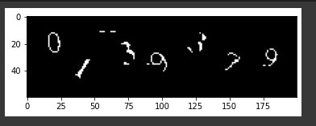

Accuracy Graph
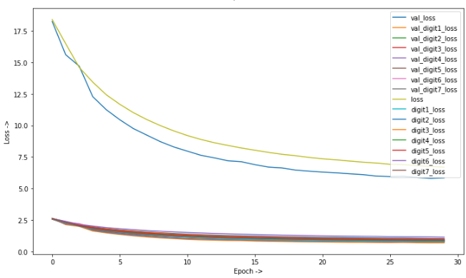
This graph represent the digit loss when epoch is increased.

Output: -
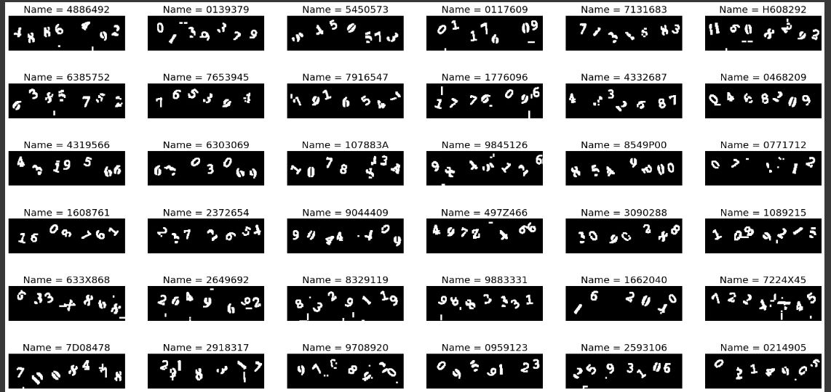

Code for numerically checking accuracy: -

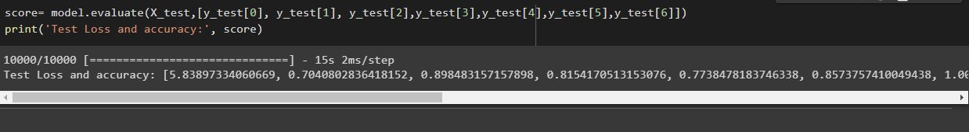

- Fish eyed Captcha
CODE -:
import glob
import tensorflow as tf
from tensorflow.keras import datasets, layers, models
import matplotlib.pyplot as plt
import numpy as np

import os
import time

import numpy as np
import pandas as pd
import os
import json
import glob
import pandas as pd
import matplotlib.pyplot as plt
import seaborn as sns
import tensorflow as tf
from PIL import Image

tf.__version__

import numpy as np
import glob
import pandas as pd
%matplotlib inline
import matplotlib.pyplot as plt
import os
#%tensorflow_version 1.x
from PIL import Image
from keras import layers
from keras.models import Model
from keras.models import load_model
from keras.utils.vis_utils import plot_model #plotting the model structure
from keras import callbacks
from datetime import datetime
import os
import cv2
import string
import numpy as np

from keras.models import Model
from keras.layers import Input, Dense, Dropout, Flatten, Conv2D, MaxPooling2D, BatchNormalization
from keras.callbacks import ModelCheckpoint, EarlyStopping, TensorBoard
import warnings
warnings.filterwarnings('ignore')
from keras import models
from keras.models import Sequential
from keras.layers import Conv2D
from keras.layers import MaxPooling2D
from keras.layers import Flatten
from keras.layers import Dense
from keras.layers import Dropout
from keras.preprocessing import image
from keras.preprocessing.image import ImageDataGenerator
from keras.callbacks import ModelCheckpoint

from keras import layers # functional
from keras.models import Model
from keras.models import load_model
from keras import callbacks
import cv2
import string
import numpy as np

from packaging import version
import tensorflow as tf
from tensorflow import keras
! unzip all_sphinx.zip > /dev/null
! echo "all_sphinx.zip has been deflated"
! rm -rf 1.zip
! rm -rf 2.zip
! rm -rf 3.zip
! rm -rf 4.zip
! rm -rf 5.zip
! rm -rf 6.zip
! rm -rf 7.zip
! rm -rf 8.zip
! echo "All the zip files have been cleaned!"
! mkdir data
! find 1 -name '*.*' | xargs mv --target-directory=data
! find 2 -name '*.*' | xargs mv --target-directory=data
! find 3 -name '*.*' | xargs mv --target-directory=data
! find 4 -name '*.*' | xargs mv --target-directory=data
! find 5 -name '*.*' | xargs mv --target-directory=data
! find 6 -name '*.*' | xargs mv --target-directory=data
! find 7 -name '*.*' | xargs mv --target-directory=data
! find 8 -name '*.*' | xargs mv --target-directory=data

png_files = glob.glob('data/*.png')
png_files[0]
img = cv2.imread(png_files[0],cv2.IMREAD_UNCHANGED)
print(img.shape)
plt.imshow(img)
plt.show()
from tqdm import tqdm
import string
index_ = {}
symbols = string.ascii_lowercase + '0123456789'
for item in symbols:
index_[item] = 0

for item in tqdm(png_files):
d = str(item.split('/')[1]).split('_')[0]
#print(d)
#break
all_c = str(d)
for i in all_c:
# if index_[i] == 0:
# index_[i] = 0
# else:
index_[i] += 1
print(index_)
index = {}
rev_index = {}
count = 0
for item in index_:
#print(item)
if index_[item]>0:
index[item] = count
rev_index[count] = item
count += 1
print(index)
print(rev_index)
#index
from matplotlib.pyplot import figure

figure(num=None, figsize=(12, 5), dpi=100, facecolor='w', edgecolor='k')
plt.bar(index_.keys(), index_.values(), width=0.9, color='#f1cb08')
plt.title('fish-eye CAPTCHA dataset frequency ')
plt.xlabel("Characters ", fontsize=10)
plt.ylabel("Frequency ", fontsize=10)
#plt.xticks(fontsize=14)
#plt.yticks(fontsize=14)
plt.show()

DATA_DIR = 'data' # 302410 images.
H, W, C = 50, 200, 3
N_LABELS = len(index)
D = 5
plt.figure(figsize=(12,7))
legend_acc = []
for item in history.history.keys():
if item.split('_')[-1:] == ['accuracy']:
#print("Accuracy = ",item)
legend_acc.append(item)
plt.plot(history.history[item])
plt.ylabel('Accuracy ->')
plt.xlabel('Epoch ->')
plt.legend(legend_acc, loc='upper left')
plt.show()

plt.figure(figsize=(12,7))
legend_acc = []
for item in history.history.keys():
if item.split('_')[-1:] == ['loss']:
#print("Accuracy = ",item)
legend_acc.append(item)
plt.plot(history.history[item])
plt.ylabel('Loss ->')
plt.xlabel('Epoch ->')
plt.legend(legend_acc, loc='upper right')
plt.show()
import math
n = 30
random_indices = np.random.permutation(n)
n_cols = 5
n_rows = math.ceil(n / n_cols)
fig, axes = plt.subplots(n_rows, n_cols, figsize=(20, 10))
for i, img_idx in enumerate(random_indices):
ax = axes.flat[i]
img_ = x_test[img_idx].copy()
#print(img_.shape)
img_1 = cv2.resize(img_, (200,50), interpolation = cv2.INTER_AREA)
ax.imshow(img_1)#.reshape((50,200,3)))
#print(y_pred[img_idx])
actual_pred = ""
true_val = ""
for ten in y_pred[img_idx]:
#print(int(ten))
actual_pred += rev_index[int(ten)]
for ten in y_true[img_idx]:
true_val += rev_index[int(ten)]
#print(actual_pred)
#break
ax.set_title('pred: {}'.format(actual_pred),fontsize=17)
#''.join(map(str, y_pred[img_idx].numpy()))))
ax.set_xlabel('true: {}'.format(true_val),fontsize=17)
#''.join(map(str, y_true[img_idx].numpy()))))
ax.set_xticks([])
ax.set_yticks([])

Sample Fish-eyed Captcha
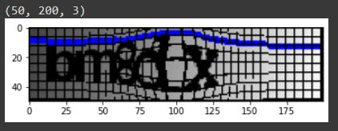
This is the sample user input for fish-eyed captcha
Frequency of character in Dataset
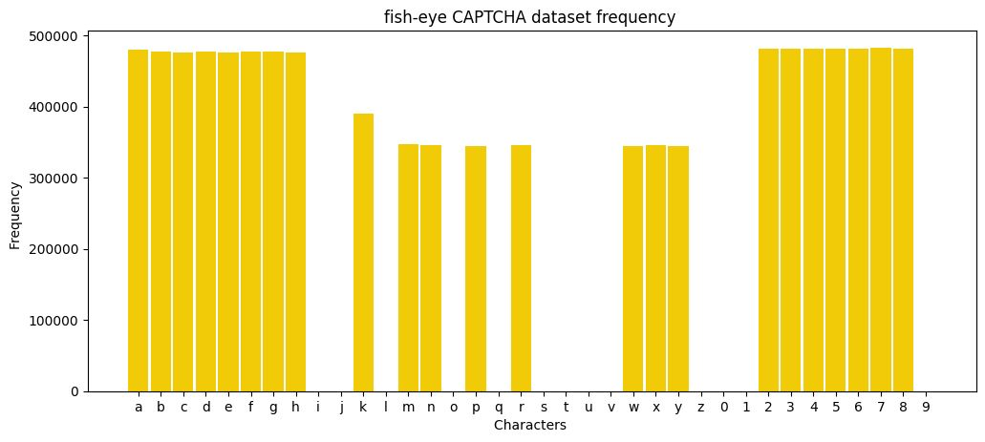
This represent how many times a particular alphabet comes in whole trained dataset.

Accuracy Graph
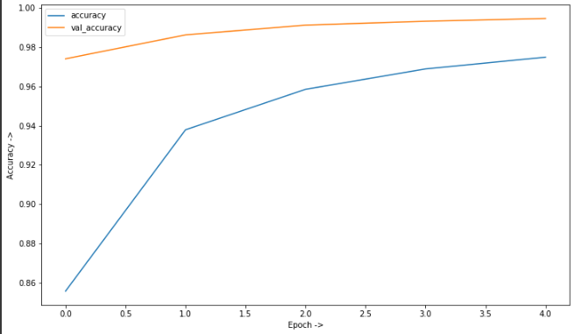
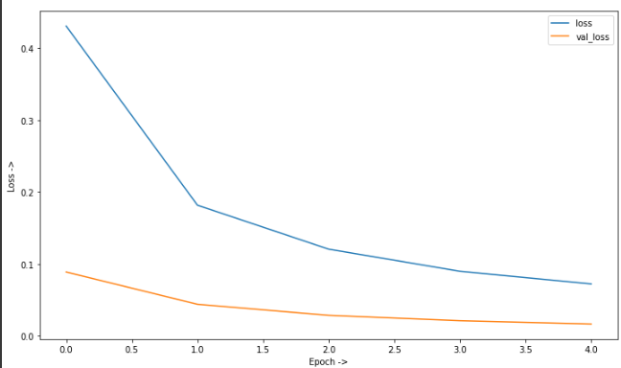

This graph represent value accuracy and accuracy of the model.

Sample input for fish eyed Captcha: -
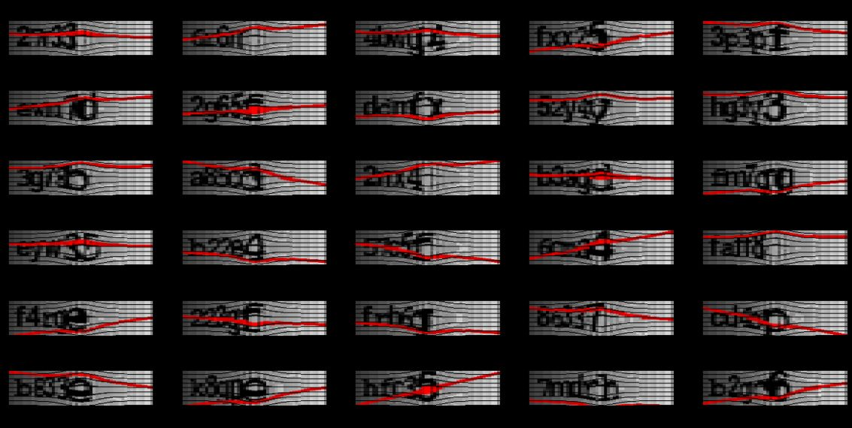

Output:
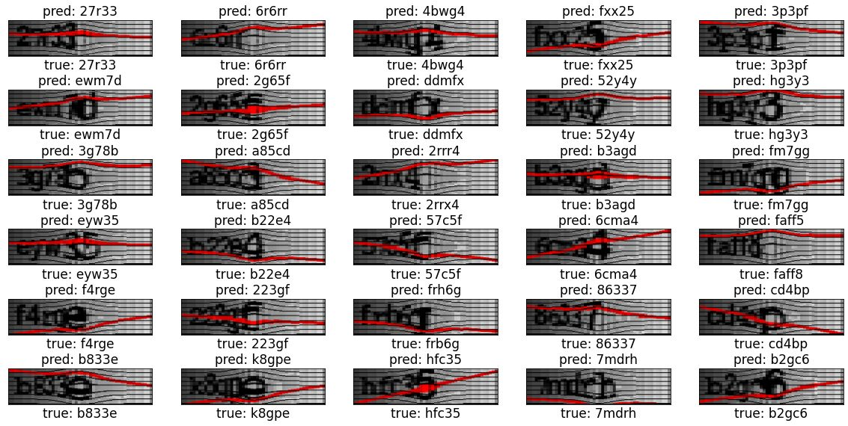

- Circle Captcha

CODE - :
import glob
import tensorflow as tf
from tensorflow.keras import datasets, layers, models
import matplotlib.pyplot as plt
import numpy as np

import os
import time

import numpy as np # linear algebra
import pandas as pd # data processing, CSV file I/O (e.g. pd.read_csv)
import os
import json
import glob
import pandas as pd
import matplotlib.pyplot as plt
import seaborn as sns
import tensorflow as tf
from PIL import Image

tf.__version__

import numpy as np
import glob
import pandas as pd
%matplotlib inline
import matplotlib.pyplot as plt
import os
#%tensorflow_version 1.x
from PIL import Image
from keras import layers
from keras.models import Model
from keras.models import load_model
from keras.utils.vis_utils import plot_model #plotting the model structure
from keras import callbacks
from datetime import datetime
import os
import cv2
import string
import numpy as np

from keras.models import Model
from keras.layers import Input, Dense, Dropout, Flatten, Conv2D, MaxPooling2D, BatchNormalization
from keras.callbacks import ModelCheckpoint, EarlyStopping, TensorBoard
import warnings
warnings.filterwarnings('ignore')
from keras import models
from keras.models import Sequential
from keras.layers import Conv2D
from keras.layers import MaxPooling2D
from keras.layers import Flatten
from keras.layers import Dense
from keras.layers import Dropout
from keras.preprocessing import image
from keras.preprocessing.image import ImageDataGenerator
from keras.callbacks import ModelCheckpoint

from keras import layers # functional
from keras.models import Model
from keras.models import load_model
from keras import callbacks
import cv2
import string
import numpy as np

from packaging import version
import tensorflow as tf
from tensorflow import keras
png_files = glob.glob('data/*.png')
png_files[0]
print(len(png_files))
img = cv2.imread(png_files[0],cv2.IMREAD_UNCHANGED)
print(png_files[0])
print(img.shape)
plt.imshow(img)
plt.show()
from tqdm import tqdm
import string
index_ = {}
symbols = string.ascii_lowercase + '0123456789' # string.ascii_uppercase +
for item in symbols:
index_[item] = 0

for item in tqdm(png_files):
d = str(item.split('/')[1]).split('_')[0]
#print(d)
#break
all_c = str(d)
for i in all_c:
# if index_[i] == 0:
# index_[i] = 0
# else:
index_[i] += 1
print(index_)
index = {}
rev_index = {}
count = 0
for item in index_:
#print(item)
if index_[item]>0:
index[item] = count
rev_index[count] = item
count += 1
print(index)
print(rev_index)
#index
from matplotlib.pyplot import figure

figure(num=None, figsize=(12, 5), dpi=100, facecolor='w', edgecolor='k')
plt.bar(index_.keys(), index_.values(), width=0.9, color='#b6fca7')
plt.title('circle CAPTCHA dataset frequency ')
plt.xlabel("Characters ", fontsize=10)
plt.ylabel("Frequency ", fontsize=10)
#plt.xticks(fontsize=14)
#plt.yticks(fontsize=14)
plt.show()
from tensorflow.keras.utils import to_categorical
from PIL import Image

def get_data_generator(df, indices, for_training, batch_size=16):
images, labels = [], []
while True:
for i in indices:
r = df.iloc[i]
file, label = r['file'], r['label']
im = Image.open(file)
im = im.resize((W, H))
im = np.array(im) / 255.0
images.append(np.array(im))
labels.append(np.array([np.array(to_categorical(index[i], N_LABELS)) for i in label]))
if len(images) >= batch_size:
# print(np.array(images), np.array(labels))
yield np.array(images), np.array(labels)
images, labels = [], []
if not for_training:
break
from tensorflow.keras.layers import Input, Dense, BatchNormalization, Conv2D, MaxPool2D, GlobalMaxPool2D, Dropout
from tensorflow.keras.optimizers import SGD
from tensorflow.keras.models import Model

input_layer = tf.keras.Input(shape=(H, W, C))
x = tf.keras.layers.Conv2D(32, 3, activation='relu')(input_layer)
x = tf.keras.layers.MaxPooling2D((2, 2))(x)
x = tf.keras.layers.Conv2D(64, 3, activation='relu')(x)
x = tf.keras.layers.MaxPooling2D((2, 2))(x)
#x = tf.keras.layers.Dropout(0.3)(x)
x = tf.keras.layers.Conv2D(64, 3, activation='relu')(x)
x = tf.keras.layers.MaxPooling2D((2, 2))(x)

x = tf.keras.layers.Flatten()(x)
x = tf.keras.layers.Dense(1024, activation='relu')(x)
x = tf.keras.layers.Dropout(0.5)(x)

x = tf.keras.layers.Dense(D * N_LABELS, activation='softmax')(x)
x = tf.keras.layers.Reshape((D, N_LABELS))(x)

model = tf.keras.models.Model(inputs=input_layer, outputs=x)

model.compile(optimizer='adam',
loss='categorical_crossentropy',
metrics= ['accuracy'])
model.summary()
plt.figure(figsize=(12,7))
legend_acc = []
for item in history.history.keys():
if item.split('_')[-1:] == ['accuracy']:
#print("Accuracy = ",item)
legend_acc.append(item)
plt.plot(history.history[item])
plt.ylabel('Accuracy ->')
plt.xlabel('Epoch ->')
plt.legend(legend_acc, loc='upper left')
plt.show()

plt.figure(figsize=(12,7))
legend_acc = []
for item in history.history.keys():
if item.split('_')[-1:] == ['loss']:
#print("Accuracy = ",item)
legend_acc.append(item)
plt.plot(history.history[item])
plt.ylabel('Loss ->')
plt.xlabel('Epoch ->')
plt.legend(legend_acc, loc='upper right')
plt.show()
import math
n = 30
random_indices = np.random.permutation(n)
n_cols = 5
n_rows = math.ceil(n / n_cols)
fig, axes = plt.subplots(n_rows, n_cols, figsize=(20, 10))
for i, img_idx in enumerate(random_indices):
ax = axes.flat[i]
img_ = x_test[img_idx].copy()
#print(img_.shape)
img_1 = cv2.resize(img_, (200,50), interpolation = cv2.INTER_AREA)
ax.imshow(img_1)#.reshape((50,200,3)))
#print(y_pred[img_idx])
actual_pred = ""
true_val = ""
for ten in y_pred[img_idx]:
#print(int(ten))
actual_pred += rev_index[int(ten)]
for ten in y_true[img_idx]:
true_val += rev_index[int(ten)]
#print(actual_pred)
#break
ax.set_title('pred: {}'.format(actual_pred),fontsize=17)
#''.join(map(str, y_pred[img_idx].numpy()))))
ax.set_xlabel('true: {}'.format(true_val),fontsize=17)
#''.join(map(str, y_true[img_idx].numpy()))))
ax.set_xticks([])
ax.set_yticks([])

Sample input for circle captcha
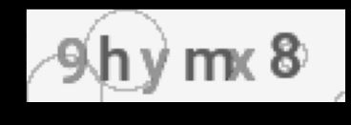
This is the sample input for Circle captcha.

Frequency of characters in dataset

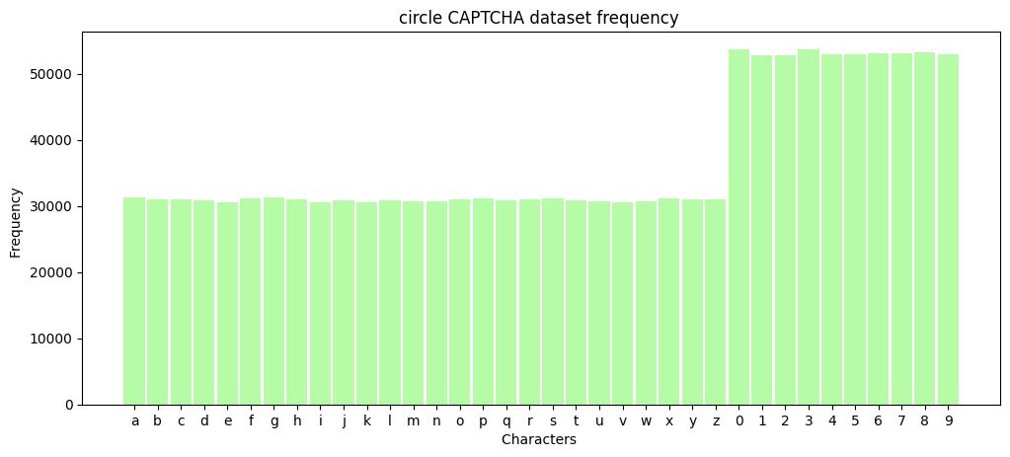
This graph shows number of times a particular character comes in whole trained dataset.

Accuracy Graph
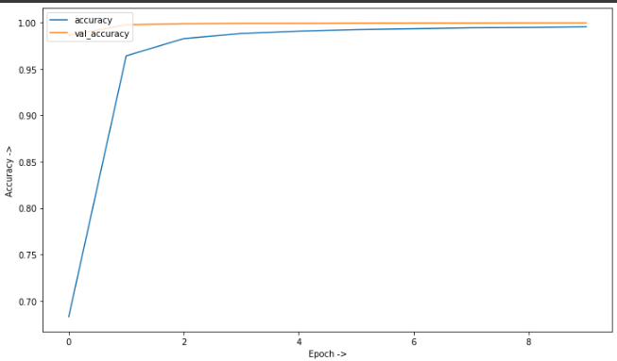
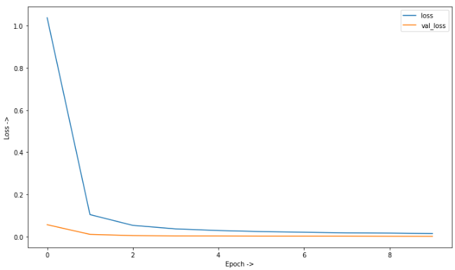

First graph shows the value accuracy and accuracy of the model
Second graph shows the value loss and loss in the model.

Sample input for circle captcha
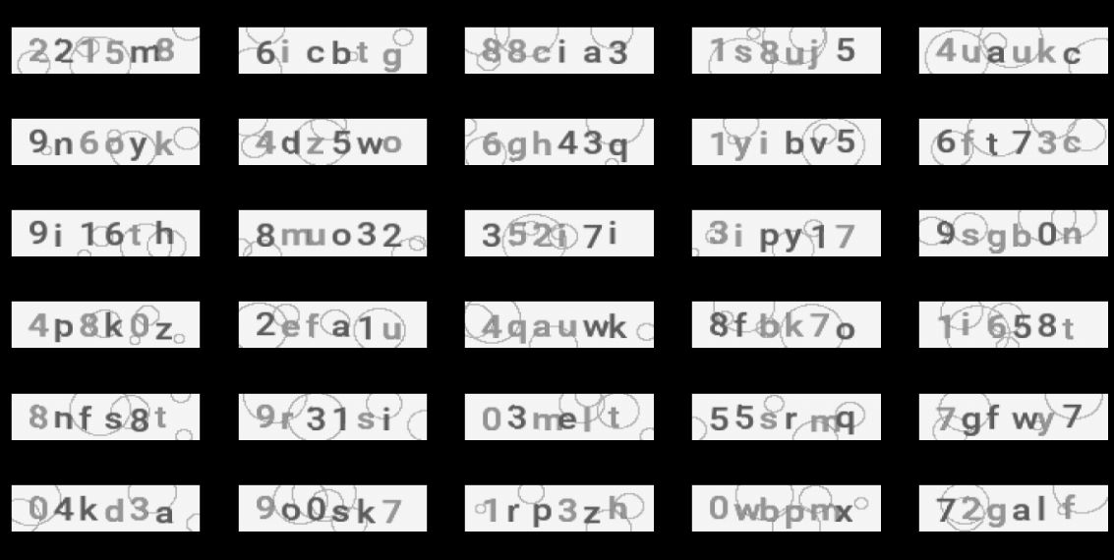

Sample output for Circle captcha
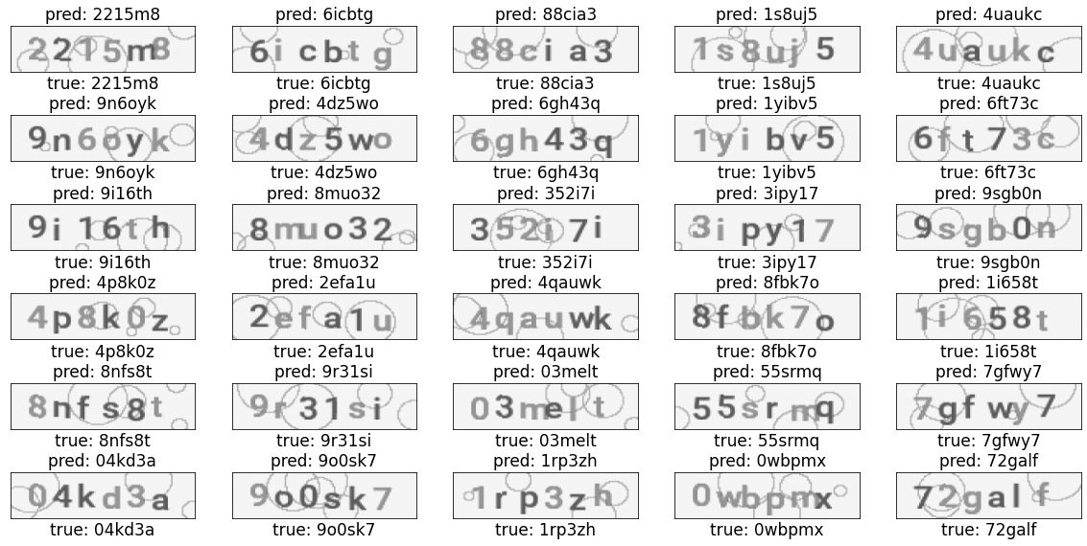

Output Screenshots
Circle Captcha
Fish-Eyed Captcha

Railway Captcha

Conclusion
Captchas have evolved into the most common security measure for safeguarding websites from bots. In this paper, we demonstrated that most captchas used by websites are readily broken and should be avoided. It is commonly known that the number of text captchas is decreasing and that new unique creative captchas are being introduced, but it is only a matter of time before someone finds a means to beat them. We've observed that speech captchas, game captchas, and puzzle captchas are more secure and difficult to defeat. Google reCAPTCHA checks if the user is human or a bot using the cookie system. As a result, these captchas should be used instead of text-based captchas.
Further study on the application of Recurrent Neural Networks as well as traditional image processing approaches to recognise and extract CAPTCHA characters, primarily individually, is recommended as part of future work. We would also advise using speech recognition algorithms and attempting to break the sound captchas.
We had no effect on the security of the websites by employing this captcha, thus we did not share our source code because of the possibility of misuse. However, we welcome researchers to contact us if they wish to utilise our model just for research purposes.
References
- https://www.google.com/url?sa=t&rct=j&q=&esrc=s&source=web&cd=&cad=rja&uact=8&ved=2ahUKEwiWxoKJv6v7AhVAUGwGHb08D4gQFnoECA8QAQ&url=https%3A%2F%2Fscholarworks.sjsu.edu%2Fcgi%2Fviewcontent.cgi%3Freferer%3D%26httpsredir%3D1%26article%3D1425%26context%3Detd_projects&usg=AOvVaw1PO5RDDI3lb_02XWjFIMOC

- https://www.google.com/url?sa=t&rct=j&q=&esrc=s&source=web&cd=&cad=rja&uact=8&ved=2ahUKEwiwzdfzpqv7AhWvTWwGHcTBAIQQFnoECA0QAQ&url=https%3A%2F%2Fwww.imperva.com%2Flearn%2Fapplication-security%2Fwhat-is-captcha%2F&usg=AOvVaw3lk5cHFx_LRRx_Vd0BuFho

- https://www.forbes.com/sites/forbestechcouncil/2019/08/07/your-captcha-could-be-hurting-your-sales/?sh=41b8999b33c8

- https://baymard.com/blog/captchas-in-checkout

- https://nsl.qatar.cmu.edu/papers/icws18.pdf

- https://app.diagrams.net/ (Draw.io)

